SD-27 SIRIO DIPOLE ANTENA DIRECTIVA RIGIDA 27 MHZ
Type: 1/2 wave Dipole
Frequency range: 26-29 MHz
Impedance: 50 Ohms unbalanced
Radiation (H-plane):
Horizontal mounting: Directional
Vertical mounting: Omnidirectional
Polarization: horizontal
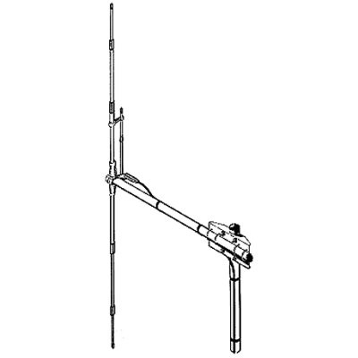

CARACTERÍSTICAS

• Gain: 0 dBd, 2.15 dBi
• Bandwidth at S.W.R. 2:1: 3750 KHz
• S.W.R. at res. freq.: = 1.1:1
• Max. power:1000 Watts (CW) Continuous, 3000 Watts (CW) short time
• Feed system / position: Gamma match / center
• Connector: UHF-female
• Boom Length: 1400mm
• Boom Diameter: 33mm
• Radiator Length (Vertical elements): 5420mm
• Radiator Diameters: 8-12-16mm
• Weight (approx): 2.5kg
• Mounting Mast Diameters: 35/50mm

