- Description
- Product Images
- Accessories

LAFAYETTE Ares Black Kit 4x4
LAFAYETTE ARES BLACK KIT 4x4. 27 Mhz CB transceiver. Color BLACK. High performance and small size transceiver. No doubt a refreshing concept of 27 Mhz transceiver. 40 channels, 4 watts AM / FM.
Kit ideal for assembling in 1 minute, fast and easy.
Easy handling, the size of the transceiver really reduced, the market's smallest!
Ideal for quickly removable installations, for 4 x 4 SUVs, campers, vehicles for trips, etc ...
This kit, once assembled no other component is necessary to operate, only assemble it and enjoy the communication with other users.
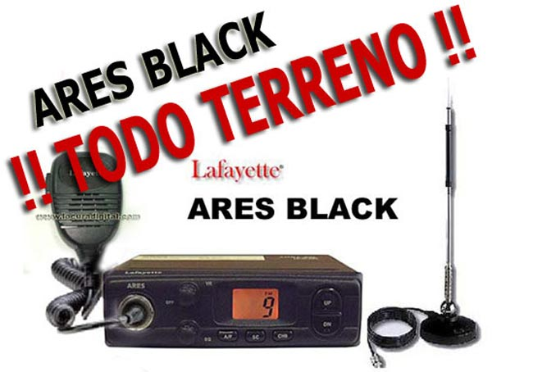
LAFAYETTE ARES BLACK KIT 4x4. 27 Mhz CB transceiver. Color BLACK.
New and innovative concept in 27 Mhz CB transceivers. With full performances this transceiver is distinguished by its small size, especially in depth dimension, ideal for those vehicles that have a small hole to place the transceiver.
Its box dimensions are 14 cm. width x 12 cms. depth x 4 cm. height. In the images screen you can find a diagram with the external dimensions of both the box as keypads and connections.
Important
E24 compliant which allows mounting electronic equipment in public transport vehicles.
You will surprise with its performance and range!
Kit contents:
- 1 LAFAYETTE ARES BLACK TRANSCEIVER
- 12V. adapter for charging from the cigarette lighter
- MAGNETIC ANTENNA MIDLAND 18-244M
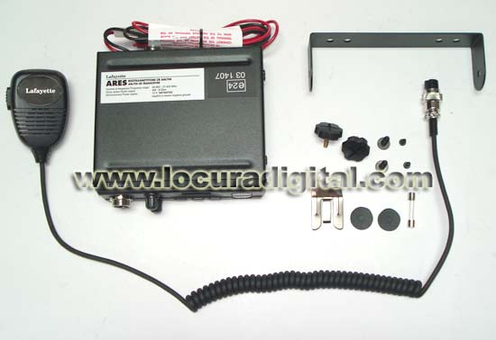

Features
- Transmitter: PLL synthesizer crystal
- Receiver: Double conversion superheterodyne system
- Operating voltage: 13.8 volts DC
- Temperature Range: -10 º C + 50 º C
- Step channel: 10 kHz.
- Power output: 4 watts AM / FM 4 watts
- Frequency Range: 26,965 to 27,405 Mhz
- Frequency Tolerance: ± 500 Hz
- Modulation sensitivity: 10 mV (1.25 kHz. Input)
- Modulation capability: AM: 90% - FM: 2 KHz
- Sensitivity: AM: 0.5 µV (s / n 10 Db) - FM: 0.3 µV (12 dB SINAD)
- Squelch: 1 µV MAX
- S / N ratio: 45 dB
- Distortion: 5%
- Maximum Power: 4 watts

