> Products > TRANSCEIVERS > CB RADIOS

LT-318 cb radio with CE
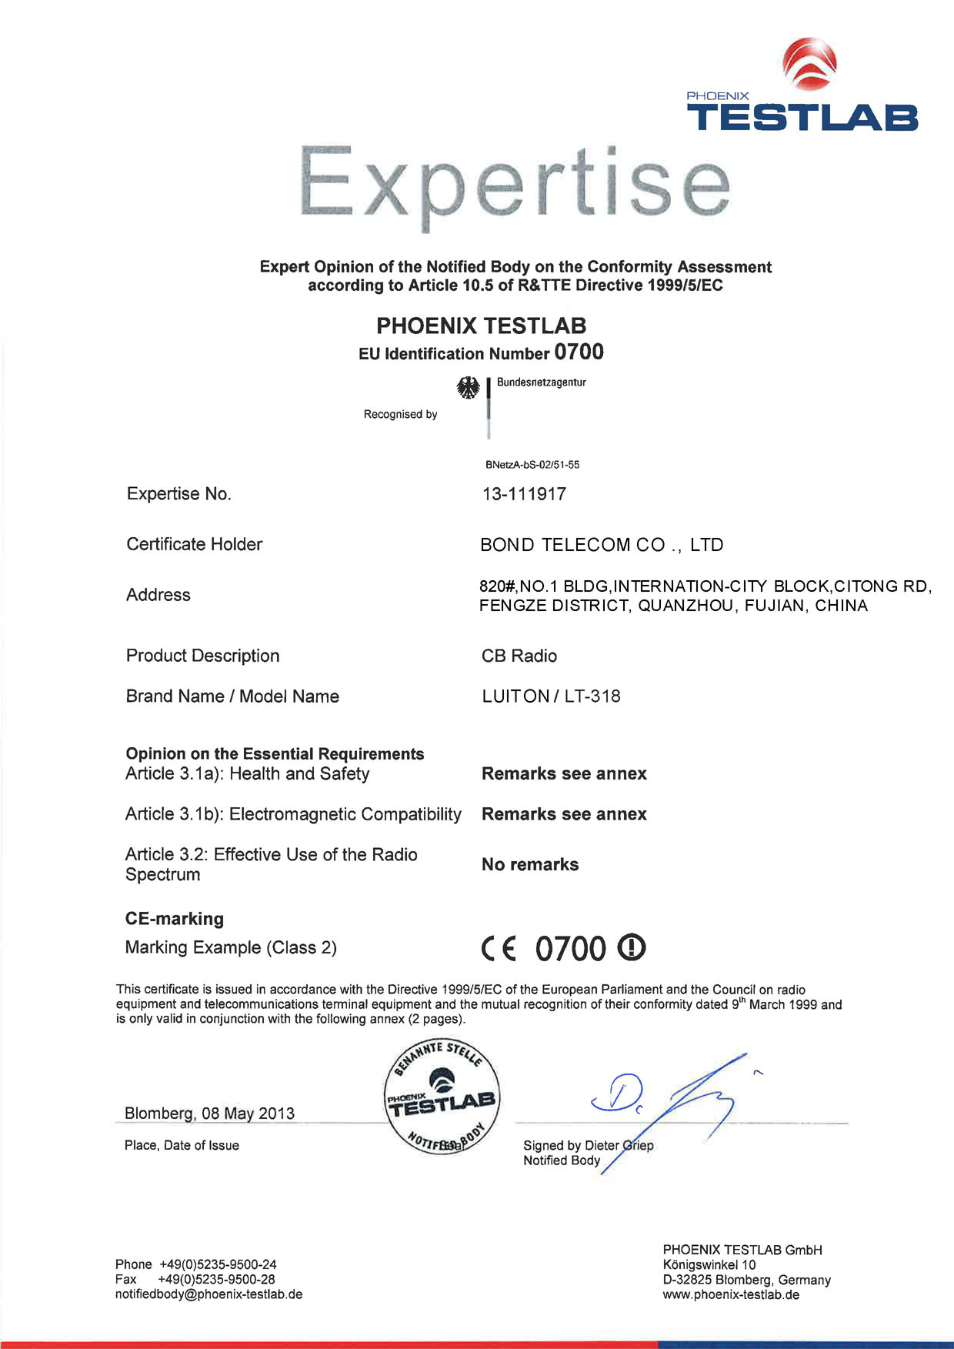
LT-318 Specification
CE Approved
AM/FM CB RADIO
Features:
PC programming
Automatic change power supply 12V/24V
High 8W/Low 4W power switchable
Wide frequency 25-30MHz
Auto scanning
Dual channel standby
Backlight selective (Red,Green,Blue)
ANL function
ASQ
Big LCD display
CH9/CH19 emergency channel
Technical Specifications:
Channel 40 FM (Saw band table)
Frequency range 25.615-30.105 MHz
Operating mode F3E (FM), A3E (AM).
Antenna impedance 50 Ohm
Speaker 8 Ohm3W
Microphone Capacitive
Power 13,6V ± 5%
Dimensions H46xL142xW158 mm
Weight 500G
RECEIVER
Sensitivity in the 12 db S/N0.5µV (AM), 0.25µV (FM)
Selectivitymore than 60dB
Noise range0.25V-500µV
Audio output power 1.5W 8 ohm (10% lost)
Distortion in 1000 µ V5%
Audio frequency response…………………………….…400-2400 Hz
Intermediate frequencyI° 10.695 MHz
II° 455 KHz
Intermodulation anti-interferencemore than 60 dB
TRANSMITTER
RF power output10% HI=10W LO=4W AM/FM
Frequency tolerance……………………………………….005%
Harmonic suppressionmore than 70 dB
Current drainHI=2200 mA LO=900 mA
Modulation mode AM 90% (± 5%)
FM dev. 2.0KHz
