Frecuencias y localizacion del repetidor UHF
Canal | Entrada | Salida |  | Canal | Entrada | Salida
R70 | 431.050 | 438.650 |  | R86 | 431.450 | 439.050
R71 | 431.075 | 438.675 |  | R87 | 431.475 | 439.075
R72 | 431.100 | 438.700 |  | R88 | 431.500 | 439.100
R73 | 431.125 | 438.725 |  | R89 | 431.525 | 439.125
R74 | 431.150 | 438.750 |  | R90 | 431.550 | 439.150
R75 | 431.175 | 438.775 |  | R91 | 431.575 | 439.175
R76 | 431.200 | 438.800 |  | R92 | 431.600 | 439.200
R77 | 431.225 | 438.825 |  | R93 | 431.625 | 439.225
R78 | 431.250 | 438.850 |  | R94 | 431.650 | 439.250
R79 | 431.275 | 438.875 |  | R95 | 431.675 | 439.275
R80 | 431.300 | 438.900 |  | R96 | 431.700 | 439.300
R81 | 431.325 | 438.925 |  | R97 | 431.725 | 439.325
R82 | 431.350 | 438.950 |  | R98 | 431.750 | 439.350
R83 | 431.375 | 438.975 |  | R99 | 431.775 | 439.375
R84 | 431.400 | 439.000 |  | R100 | 431.800 | 439.400
R85 | 431.425 | 439.025 |  | R101 | 431.825 | 439.425
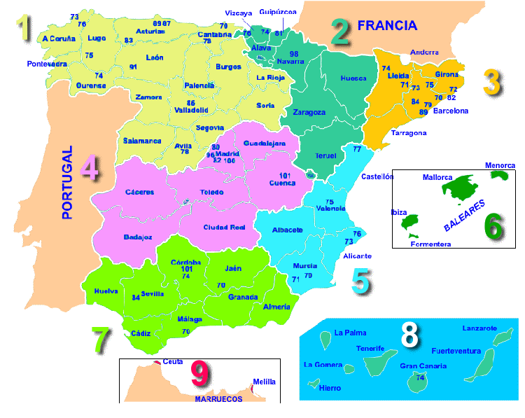
Frecuencias y localizacion del repetidor VHF
Repetidor | Entrada | Salida
R0 | 145.000 | 145.600
R1 | 145.025 | 145.625
R2 | 145.050 | 145.650
R3 | 145.075 | 145.675
R4 | 145.100 | 145.700
R5 | 145.125 | 145.725
R6 | 145.150 | 145.750
R7 | 145.175 | 145.775
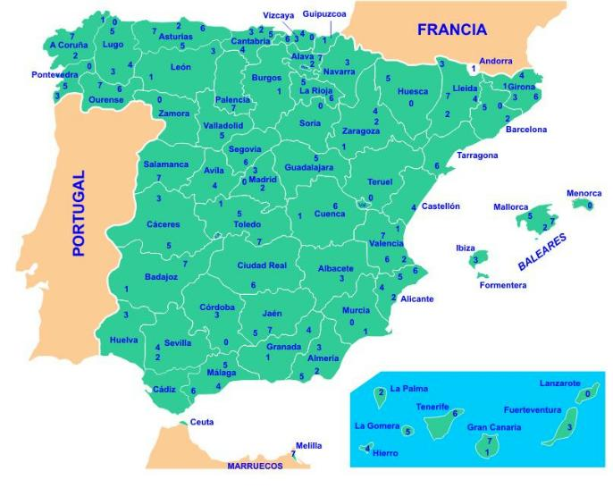
Frecuencias CB 27
Número canal | Frecuencia MHz | Número canal | Frecuencia MHz
1 | 26,965 | 21 | 27,215
2 | 26,975 | 22 | 27,225
3 | 26,985 | 23 | 27,255
4 | 27,005 | 24 | 27,235
5 | 27,015 | 25 | 27,245
6 | 27,025 | 26 | 27,265
7 | 27,035 | 27 | 27,275
8 | 27,055 | 28 | 27,285
9 | 27,065 | 29 | 27,295
10 | 27,075 | 30 | 27,305
11 | 27,085 | 31 | 27,315
12 | 27,105 | 32 | 27,325
13 | 27,115 | 33 | 27,335
14 | 27,125 | 34 | 27,345
15 | 27,135 | 35 | 27,355
16 | 27,155 | 36 | 27,365
17 | 27,165 | 37 | 27,375
18 | 27,175 | 38 | 27,385
19 | 27,185 | 39 | 27,395
20 | 27,205 | 40 | 27,405
Frecuencias PMR
Canal | Frecuencia
1 | 446.006.25
2 | 446.018.75
3 | 446.031.25
4 | 446.043.75
5 | 446.056.25
6 | 446.068.75
7 | 446.081.25
8 | 446.093.75
Codigos o subtonos CTCSS
Tono | Frecuencia | Tono | Frecuencia | Tono | Frecuencia | Tono | Frecuencia | Tono | Frecuencia
01 | 67.0 Hz | 09 | 91.5 Hz | 17 | 118.8 Hz | 25 | 156.7Hz | 33 | 210.7 Hz
02 | 71.9 Hz | 10 | 94.8 Hz | 18 | 123.0 Hz | 26 | 162.2 Hz | 34 | 218.1 Hz
03 | 74.4 Hz | 11 | 97.4 Hz | 19 | 127.3 Hz | 27 | 167.9 Hz | 35 | 225.7 Hz
04 | 77.0 Hz | 12 | 100.0 Hz | 20 | 131.8 Hz | 28 | 173.8 Hz | 36 | 233.6 Hz
05 | 79.7 Hz | 13 | 103.5 Hz | 21 | 136.5 Hz | 29 | 179.9 Hz | 37 | 241.8 Hz
06 | 82.5Hz | 14 | 107.2 Hz | 22 | 141.3 Hz | 30 | 186.2 Hz | 38 | 250.3 Hz
07 | 85.4 Hz | 15 | 110.9 Hz | 23 | 146.2 Hz | 31 | 192.8 Hz
08 | 88.5 Hz | 16 | 114.8 Hz | 24 | 151.4 Hz | 32 | 203.5 Hz
Codigos o subtonos DCS
DCS | Freq | DCS | Freq | DCS | Freq | DCS | Freq | DCS | Freq | DCS | Freq | DCS | Freq | DCS | Freq | DCS | Freq
001 | 023 | 013 | 071 | 025 | 143 | 037 | 225 | 049 | 266 | 061 | 356 | 073 | 452 | 085 | 532 | 097 | 703
002 | 025 | 014 | 072 | 026 | 145 | 038 | 226 | 050 | 271 | 062 | 364 | 074 | 454 | 086 | 546 | 098 | 712
003 | 026 | 015 | 073 | 027 | 152 | 039 | 243 | 051 | 274 | 063 | 365 | 075 | 455 | 087 | 565 | 099 | 723
004 | 031 | 016 | 074 | 028 | 155 | 040 | 244 | 052 | 306 | 064 | 371 | 076 | 462 | 088 | 606 | 100 | 731
005 | 032 | 017 | 114 | 029 | 156 | 041 | 245 | 053 | 311 | 065 | 411 | 077 | 464 | 089 | 612 | 101 | 732
006 | 036 | 018 | 115 | 030 | 162 | 042 | 246 | 054 | 315 | 066 | 421 | 078 | 465 | 090 | 624 | 102 | 734
007 | 043 | 019 | 116 | 031 | 165 | 043 | 251 | 055 | 325 | 067 | 413 | 079 | 466 | 091 | 627 | 103 | 743
008 | 047 | 020 | 122 | 032 | 172 | 044 | 252 | 056 | 331 | 068 | 423 | 080 | 503 | 092 | 631 | 104 | 754
009 | 051 | 021 | 125 | 033 | 174 | 045 | 255 | 057 | 332 | 069 | 431 | 081 | 506 | 093 | 632
010 | 053 | 022 | 131 | 034 | 205 | 046 | 261 | 058 | 343 | 070 | 432 | 082 | 516 | 094 | 654
011 | 054 | 023 | 132 | 035 | 212 | 047 | 263 | 059 | 346 | 071 | 445 | 083 | 523 | 095 | 662
012 | 065 | 024 | 134 | 036 | 223 | 048 | 265 | 060 | 351 | 072 | 446 | 084 | 526 | 096 | 664

