124WB CUSHCRAFT | 127,00 €

144-148 MHZ 4 ELEMENTOS, GAIN 10,2DB.
Model | 124WB
3dB Beamwidth, Degrees E-Plane | 60
3dB Beamwidth, Degrees H-Plane | 88
Boom Lenght ft.(m) | 4(1.22)
Electrical Wavelength | .5
Forward Gain, dBi | 10.2
Frequency, MHz | 144-148
Front to Back Ratio, dB | 19
Longest Element in(cm) | 40.75 (104)
Mast size range, in.(cm) | 1.25-2 (3.8-5.1)
No. Elements | 4
Power Rating, Watts PEP | 2000
Side Lobe Atten., dB, E-Plane | 40
SWR 1.2:1 Typical 2:1 Bandwidth, MHz | 6
Turning Radius ft(m) | 4 (1.22)
Weight, lb(kg) | 21.5 (9.75)
Wind load ft (m) sq | 4.84 (.45)
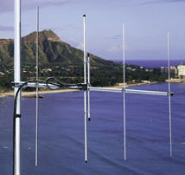
Este producto sobrepasa 1 metro de longitud embalado. Serán añadidos 7€ de recargo adicionales de suplemento de transporte.

