- Description
- Product Images
- Handbook

COBRA-75 ST-EU
-75ST-EU COBRA COBRA CB 27 Mhz. AM / FM 40 channels.
Joined cigarette lighter plug to power in your vehicle quickly and effectively facilitating the assembly and disassembly of this station in a very simple
Direct access to channels 19
- Display channel indicator
- Selectors UP / DOWN in front
- Volume Control
- Squelch Control
- Tx Led indicator
- Socket for external speaker
- Micro Connector 4 pin
- SO239 antenna connector
- lighter connector built
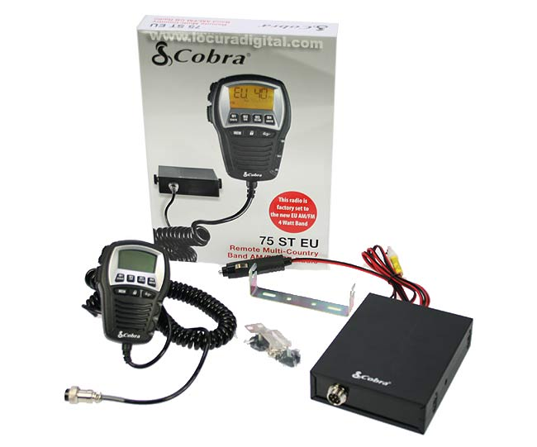
Kit Contents COBRA 75 ST-EU
- 1 RADIO COBRA 75
- 1 POWER CABLE CONNECTOR WITH LIGHTER
- 1 BRACKET IS STABLE
- 1 BRACKET MICROPHONE
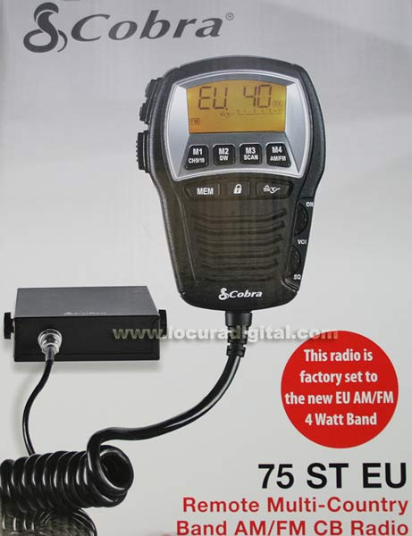
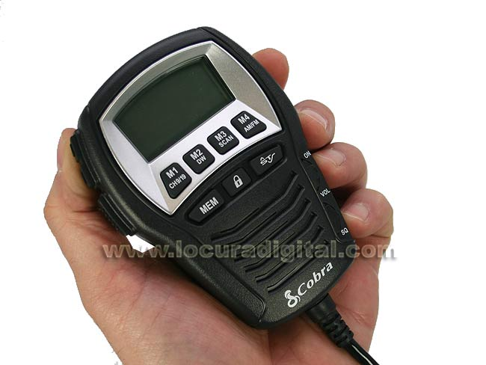
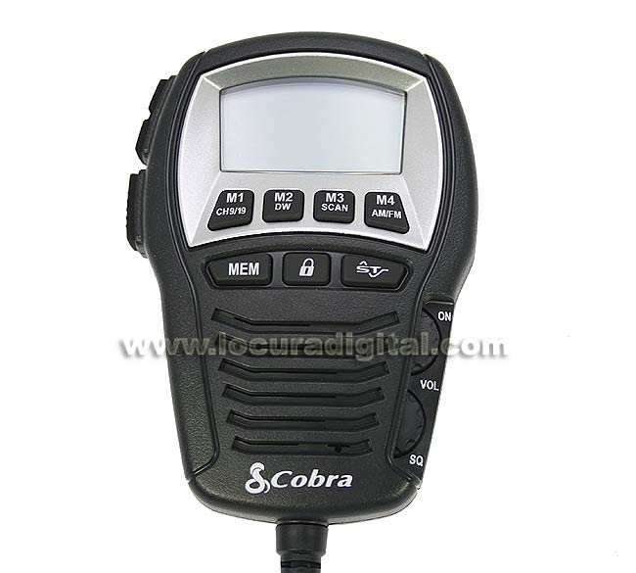
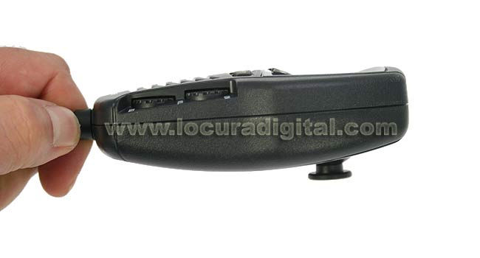
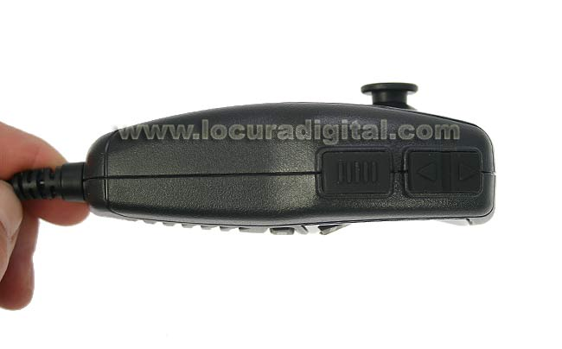
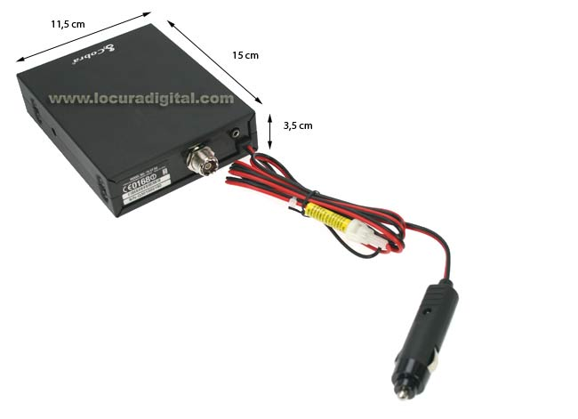
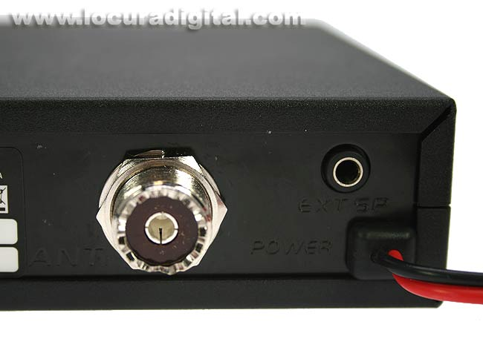
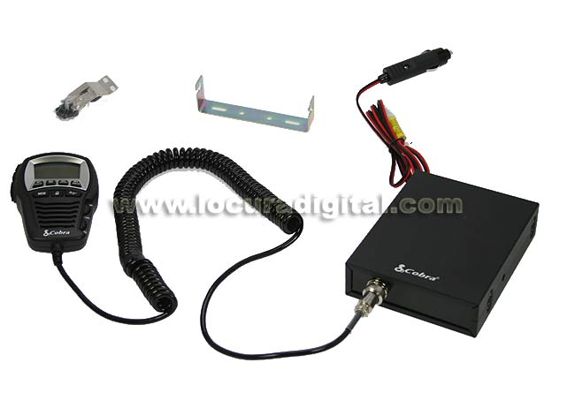
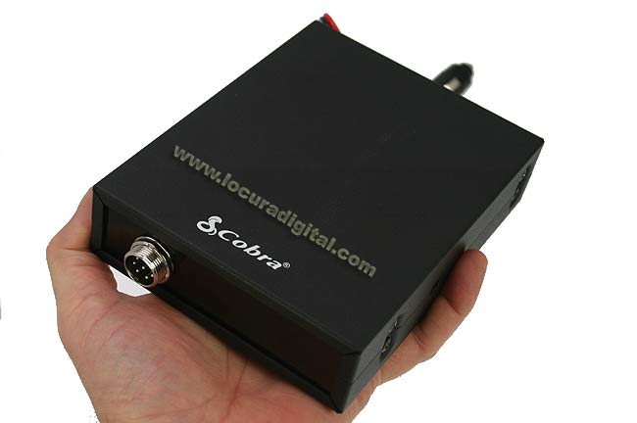

Features
- Direct access to channels 9 and 19
- Display channel indicator
- Selectors UP / DOWN in front
- Volume Control
- Squelch Control
- Tx Led indicator
- Socket for external speaker
- Micro Connector 4 pin
- SO239 antenna connector
- lighter connector built

