Cobra 29 LX
Cobra 29 LX EU COBRA Emisora CB 27 Mhz. AM / FM
Cobra 29 LX es un dispositivo de CB móvil con un diseño moderno e innovador. La luz de fondo está disponible en cuatro colores intercambiables, ideal para adaptar en las condiciones del día y de noche. Como se ha sabido de los modelos Cobra anteriores del fabricante una vez más se integra la función SoundTracker que ofrece una mejor recepción.
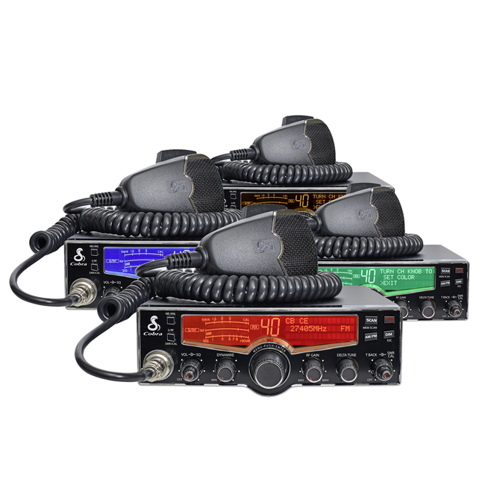
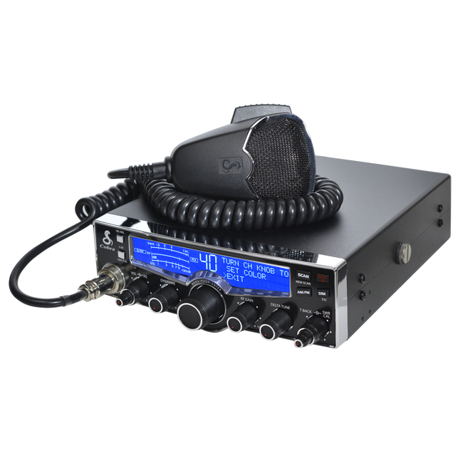
Kit Contents
- 1 RADIO COBRA 29 XL
- 1 Power
- 1 bracket to hold station
- 1 Microphone

Features

Channels | - Multi-standard function
Modes | - AM / FM Output Power 4 watts
Features & Functions | - backlit LCD modern (contrast and brightness adjustment)  - Time display (including alarm and countdown )  - sound tracker feature for clear reception  - ANL and NB-function  - Adjusting the microphone sensitivity  - Test mode (device checks the voltage, output power, and displays the result on the screen)  - RF Gain Control (for optimization of the recipient)  - 10 channels storage of frequently used frequencies  - S-miter digital  - digital RF meter  - Exploration  - adjustable muffler  - Quick access to channel 9 and 19  - Keypad tones ( off)  - Reset  - Part Connection for external speakers (3.5 / 8 ohms)  - Connection for external S-meter (2.5 mm)
Microphone connector | - 4-pin
Power Supply | - 13,2 V DC (max. 1.4"0in TX)
Dimensions in mm (WxHxD) | - 184 x 71 x 219 (without protrusions)
Weight | - 1.8 kg

