AR-6 CUSHCRAFT | 111,00 €

50-54 MHZ. RINGO. GAIN 3DB
Model | AR6
Frequency, MHz | 50-54
Gain, dBi | 3
Height, ft(m) | 10.1(3.1)
Horizontal Radiation Pattern  Degrees | 360
Mast size range, in.(cm) | 1-1.25(2.54-3.1)
Power Rating, Watts FM | 1000
Radiation angle, deg. | 16
Radiator Base Dia, in(cm) | 1(2.5)
Ring Diameter in(cm) | 13(33)
SWR 1.2:1 Typical 2:1 Bandwidth, MHz | 2
Weight, lb(kg) | 2.5(1.1)
Wind load ft (m) sq | .37(.03)
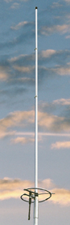
Este producto sobrepasa 1 metro de longitud embalado. Serán añadidos 7€ de recargo adicionales de suplemento de transporte.

