- Description
- Product Images
- Handbook

ALAN-MIDLAND 8001 XT
ALAN-MIDLAND 8001 XT. CB Transceiver AM / FM / SSB! NEW MODEL for 2012!
AM / FM / SSB CB radio.
External Squelch.
RF and Microphone Gain control.
SWR meter.
AM-FM-LSB-SSB Selector.
Clarifier.
Automatic NB / ANL.
ECO switch.
26,965 - 27,405MHz frequency range.
Output power: AM/FM 4W – SSB 12W.
Classic design.
4 pin Microphone.
Dimensions: 200 x 60 x 235mm.
Weight: 1,678KG.
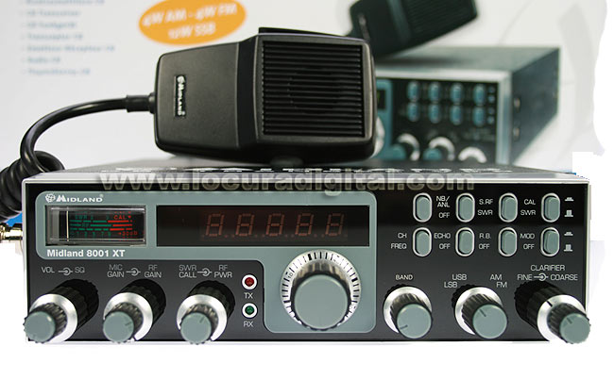

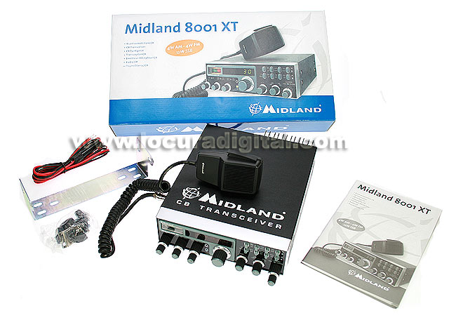

Features
- AM / FM / SSB CB radio.
- External Squelch.
- RF and Microphone Gain control.
- SWR meter.
- AM-FM-LSB-SSB Selector.
- Clarifier.
- Automatic NB / ANL.
- ECO switch.
- 26,965 - 27,405MHz frequency range.
- Output power: AM/FM 4W – SSB 12W.
- Classic design.
- 4 pin Microphone.
- Dimensions: 200 x 60 x 235mm.
- Weight: 1,678KG.

